1. Research the Department of Foreign Affairs and Trade Website**:**

Foreign Trade Activities

[**http://dfat.gov.au/trade/resources/trade-at-a-glance/pages/default.aspx**](http://dfat.gov.au/trade/resources/trade-at-a-glance/pages/default.aspx)

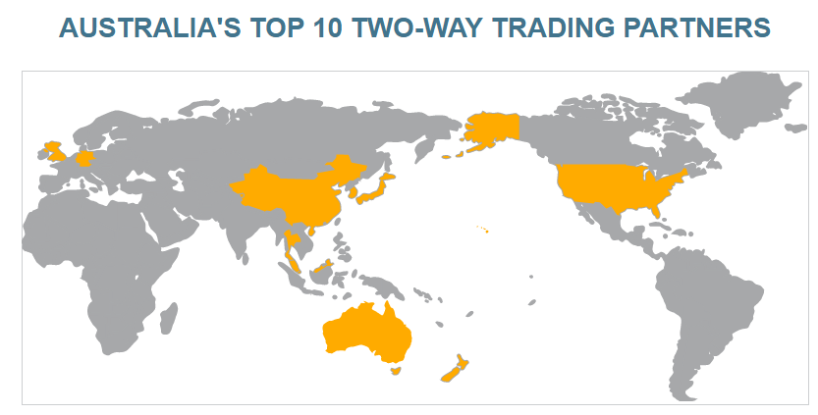

**Which goods make up most of Australia's imports from Singapore, Thailand and Malaysia?**

|  |  |  |
| --- | --- | --- |
| Singapore | Thailand | Malaysia |
|  |  |  |
|  |  |  |
|  |  |  |
|  |  |  |
|  |  |  |
|  |  |  |

**Which goods make up most of Australia's exports to the United States and New Zealand?**

|  |  |  |
| --- | --- | --- |
| United States | | New Zealand |
|  |  | |
|  |  | |
|  |  | |
|  |  | |
|  |  | |
|  |  | |

1. Think back to the time you spent between waking up this morning and arriving at school. Make a list of all the goods and services that you consumed between this time. Are these goods and services produced locally or are they imported?
2. You are going to do an audit of 20 items from your home (a mix of clothing, foods, electronics etc). Make a list of your items noting down what they are and where they are made.

|  |  |  |
| --- | --- | --- |
| Item | Description (brand etc) | Where was the item made? |
| 1. |  |  |
| 2. |  |  |
| 3. |  |  |
| 4. |  |  |
| 5. |  |  |
| 6. |  |  |
| 7. |  |  |
| 8. |  |  |
| 9. |  |  |
| 10. |  |  |
| 11. |  |  |
| 12. |  |  |
| 13. |  |  |
| 14. |  |  |
| 15. |  |  |
| 16. |  |  |
| 17. |  |  |
| 18. |  |  |
| 19. |  |  |
| 20. |  |  |

*In your next lesson we will discuss what you have all found in your homes and we will collate some data on this.*

1. Clearly, foreign trade is not always a positive thing, even though it can produce improved economic outcomes for some parties in the supply chain. One major concern Australians face is the challenge of keeping up with cheaper imports. In many cases, due to low-cost labour and resources, it is cheaper to purchase a product made overseas than to make it here in Australia. You may have heard news reports about factories closing down and operations being moved ‘offshore’ as a way to reduce production costs and improve a business’s profitability. The concern for employees is that where the production goes, so too do the jobs. Unemployment and business closure as a result of international trade is a very real phenomenon.

**Activity 1**

Scenario: Businesses in the Australian dairy industry produce milk and other dairy products to sell within Australia and to export to the global market. The dairy industry in India has been growing rapidly, due to cheaper wages and factory farming, and they have begun to export their cheaper products to Australia. They are hugely popular with Australian consumers. This is a threat to the local industry!

The table below shows the price difference between the products:

|  |  |
| --- | --- |
| **Australian Milk** | **Indian Milk** |
| Cost to produce 1L = $0.80 | Cost to produce and export 1L = $0.50 |
| Retail Price for 1L = $1.50 | Retail Price for 1L = $1.00 |
| Profit Margin per Litre = $0.70 | Profit Margin per Litre = $0.50 |

Describe the pros and cons of using Australian Milk and Indian Milk.

|  |  |  |
| --- | --- | --- |
| **Option** | **Pros** | **Cons** |
|  |  |  |
|  |  |  |

**Activity 2.** Sometimes, businesses and trade unions successfully lobby governments to take action on behalf of local industries. But how does the government do this?

Now, imagine you are the Federal Trade Minister. The head of the dairy industry in Australia has come to you looking for a solution. Brainstorm 3 ways the government could protect the local industry:

|  |  |  |
| --- | --- | --- |
| **Option** | **Pros** | **Cons** |
|  |  |  |
|  |  |  |
|  |  |  |

1. Take a look at the images below. For each image, provide a caption that explains the argument for/against global trade that is being suggested:

LOWER 
PRICE 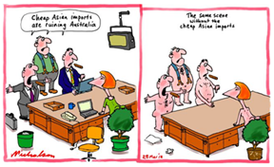

1. Consider when we import goods from China/India/Bangladesh (low cost economies)

*Like that really cheap shirt you bought at Kmart.*

*What is good/bad about our ability to trade with these countries?*

|  |  |  |
| --- | --- | --- |
| **Positives** | **Negatives** | **Potential solution (to overcome negative impacts)** |
|  |  |  |
|  |  |  |
|  |  |  |
|  |  |  |
|  |  |  |
|  |  |  |